Monthly
Newsletter
Volume1 | Issue 1 | News Letter
Announcement  Newsletter is now published please pass it on to other men.  Please make sure you sign up for the monthly newsletter where there will be announcements of coming events for the District Men’s Ministry.  If you would like to contribute an article to be published here, please send it to theacc75@outlook.com title the email article for newsletter.  Out next event is May 5th and 6th at Delta Lake the Spring Men’s Retreat put it on your Calendar and let’s make it Great!! |  | Inside This Issue  PG. 2  Christmas Greeting

Christmas Challenge  The Calendar says December 25th is just a few weeks away, so much to do, shopping for that special gift which no one seems to have, Children’s Christmas Programs to attend, not to mention decorating the Church and getting ready for that all too important Christmas Service. Wow, we are busy!  Maybe just a bit too busy, why are we doing all this? Is this what God is expecting from us? What about the old couple down the street who spend most Christmases alone with no family left? Or the young family in town barley able to afford food let alone presents for their young child? Maybe you know someone in the local nursing home, or Hospital.  We get selfish at Christmas; we think only of our own families and the smiles on Christmas day. God’s love is for everyone, as Christians we have an obligation to share that love and Joy with all God’s Children. |  | 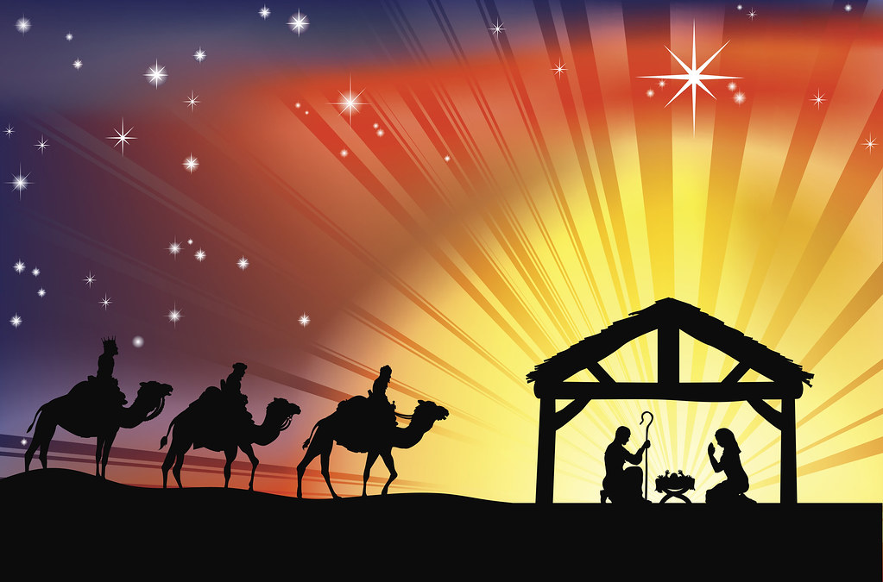
“A Child Is Born a Son Is Given.” |  | A Fateful Night Changed the World.  How Great a Love does Jesus have for us. Jesus Said in the book of John 8:58 “Very truly I tell you,” Jesus answered, “before Abraham was born, I am!” The one with no beginning and no end stepped out of Heaven and became one of us. Not born in a palace but in a manger.  A great promise was made by God that a Savior would be given for the redemption of all mankind for the sin that has plagued us since Adam and Eve. That night changed the direction and future of the world, no longer having to live in darkness but now being allowed to see the light!  The greatest gift will never be found in a store, can never be purchased is free for all to receive, will never be found under a tree, but in the Hearts of all who will accept the free gift given by our Father, His son Jesus. Amen

